**Creating a Dev Scratch Org**

Components needed:

* CCI: <https://cumulusci.readthedocs.io/en/latest/get_started.html>
* https://cumulusci.readthedocs.io/en/latest/get_started.html#on-windows
* <https://github.com/UniversityOfSaintThomas/UST-EASY>
* Install GitHub Desktop
* Install Git in IntelliJ
* Make sure that Python is installed & Path is updated
  + Note: Python must be updated in the System Variables Path, not User Variables.
* Install CCI
* Install SFDX

After installing & configuring the above items, follow the steps below to get started.

1. Open GitHub Desktop
2. Click File – Clone Repository
3. Find the UST-EASY, then click Clone.
4. Now switch to IntelliJ
5. Verify that Git has been installed in IntelliJ
6. File – Open – and find the folder where we cloned the repository, then click Ok.

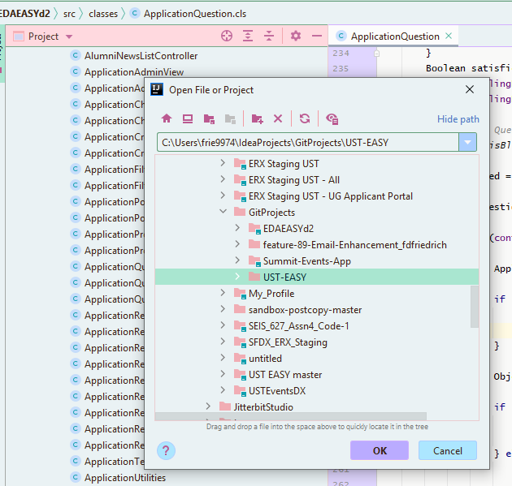

1. Ignore any errors for now.
2. Open the IntelliJ Terminal

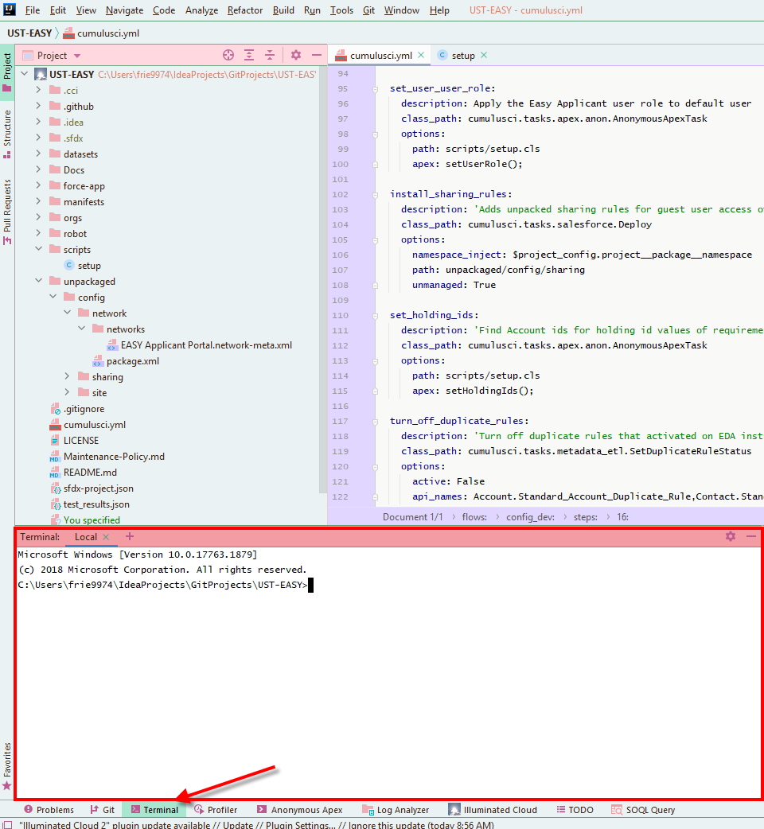

* 1. Altnernate: Use Windows cmd
     1. Windows+R to open a run box
     2. Type “cmd” in the box, and click enter

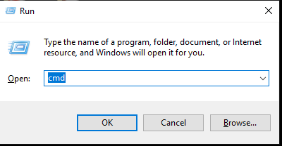

* + 1. Navigate to your directory (cd IdeaProjects\GitProjects\UST-EASY)

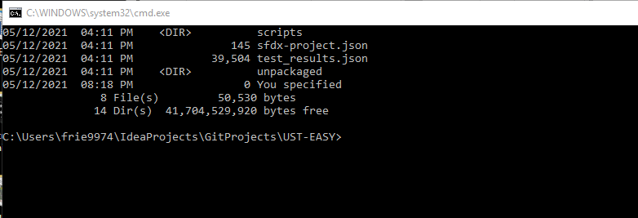

* + 1. Now you can proceed with the remaining instructions using Windows cmd instead of IntelliJ

1. Verify the org structure: cci org list
2. Verify the orgs look similar:

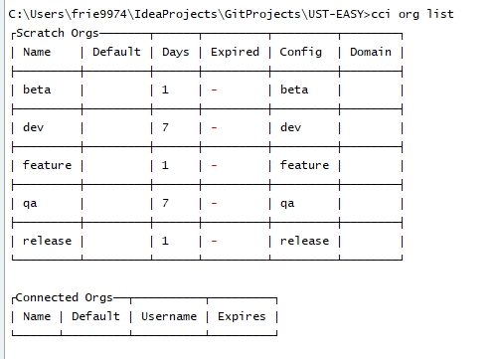

1. Set dev as the default org: cci org default dev
2. Enable dev hub: sfdx force:auth:web:login --setdefaultdevhubusername --setalias my-hub-org
3. A browser window will open. Log into Salesforce EDA Production, then close or minimize the browser window.
4. Create the scratch org: cci flow run dev_org
   1. If you run into an issue and need to start over: cci org remove dev
5. Open the scratch org: cci org browser
6. Once in the Salesforce org, navigate to Setup - Login Flows
7. Click New, and set it up like this:

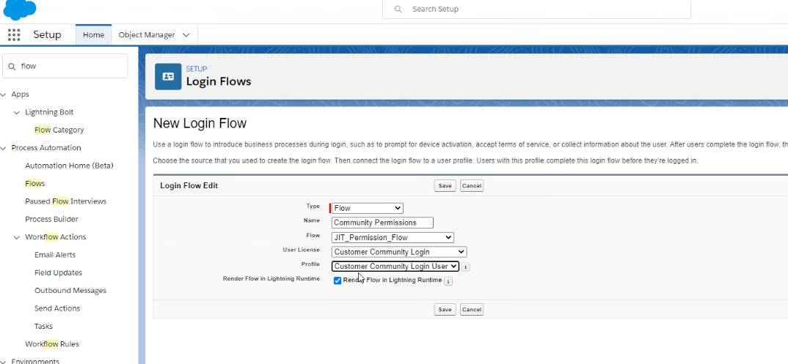

1. Next, you need to finish the community setup. Go to the Setup – Sites – Workspaces, Administration, Login & Registration, and set Account to Applicant Parent Account.

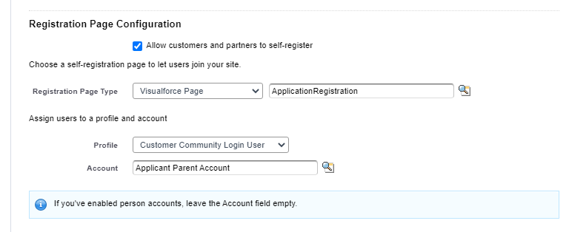

1. Optional: Setup State & Country picklists – run the scan, then convert them all
   1. Note: this takes a lot of time. You only need to set these up if you will be using them.
2. Copy the site URL that was created & update your browser bookmarks for testing/accessing later (in incognito mode)
   1. Guest user: [Site Guest User, EASY Applicant Portal](https://uofstthomasmn--edaeasyd2.my.salesforce.com/00519000003U4Oj)

Congratulations! Your scratch org is ready for use!

**Random helpful CCI Commands**

* 1. Upgrade CCI: pipx upgrade cumulusci
  2. CCI Service list
  3. Update sfdx: sfdx update
  4. cci version
  5. cci org browser dev
  6. sfdx force:auth:web:login --setdefaultdevhubusername --setalias my-hub-org
  7. cci org default dev
  8. cci org list (to verify that it is set as org)
  9. See changes made in the org
     1. cci task run list_changes --org dev
     2. cci task run list_changes --org dev -o exclude "Profile"
        1. --exclude Profile,Network,Blah
  10. Retrieve the changes
      1. cci task run retrieve_changes --org dev -o exclude "Profile"
  11. Data: <https://cumulusci.readthedocs.io/en/latest/data.html>
      1. Generate data set:
         1. Generate data mapping
            1. cci task run generate_dataset_mapping –org {orgname}
            2. cci task run generate_dataset_mapping --org dev
         2. cci task run extract_dataset -o mapping datasets/mapping.yml -o sql_path datasets/data.sql --org dev
         3. Cci task run retrieve_changes –exclude Profile,ListView,PicklistValue
         4. Review datasets\data.sql and remove data as needed.
         5. Copy files (data.sql and mapping.yml) to your own directory.
         6. Make sure the Network fold isn’t in the force-app, main directory
      2. cci task run generate_dataset_mapping --org dev
      3. cci task run extract_dataset -o database_url "" -o mapping datasets\generated_mapping.yml -o sql_path datasets\test_data.sql --org dev
      4. Delete Data
         1. cci task run delete_data -o objects Interaction_Mapping__c,hed__Language__c,EASY_Widget__c,Program__c,Intended_Program_Term__c,Academic_Term__c,Plan__c,Requirement__c,Requirement_Item__c,Question__c,Question_Dependency__c,Application_Control__c, ,hed__Term__c, Admission_Region__c,Admission_Territory__c --org {devorgname}
            1. Must delete in reverse order of insert
         2. Can use SOQL in Delete statement
            1. cci task run delete_data -o objects Account -o where "StageName = 'Active' " --org dev
  12. Push changes: git status, which will open github desktop, then update your notes about change and commit to master (or to your own branch).
  13. Check branch: git branch
  14. Push changes to scratch org: cci task run dx_push
  15. To delete an org: cci org remove dev
  16. Refresh token sfdx force:auth:web:login -r [https://test.salesforce.com](https://test.salesforce.com/)
  17. To generate a password for the scratch org user: sfdx force:user:password:generate --targetusername <username>
      + 1. <https://developer.salesforce.com/docs/atlas.en-us.sfdx_dev.meta/sfdx_dev/sfdx_dev_scratch_orgs_passwd.htm>
  18. Add dev org as a persistent org
      1. cci org connect {devorgname} --global-org --login-url [https://test.salesforce.com](https://test.salesforce.com/)
         1. dev org name can be whatever you want to call it as a org reference